Summary of USA Site Qualification Modules Assembled

- Overview of Qualification Modules

The USA site qualification modules are:

Module Number | Hybrid Type | ASIC Wafer | Baseboard Type | Hamamatsu Detector Type
20220040200004  (Q1) | K5 | UCSC-Z38850-W16-2 | Site qualification, new washers | Pre-series  100
20220040200003  (Q2) | K5 | UCSC-Z38850-W16-2 | Site qualification, new washers | Pre-series  100
20220040200006  (Q3) | K5 | UCSC-Z38850-W20 | Site qualification, new washers | Pre-series  100
20220040200007 (Q4) | K5 | UCSC-Z38850-W20 | Site qualification, new washers | Pre-series  100
20220040200005  (Q5) | K5 | UCSC-Z38850-W20 | Site qualification, new washers | Pre-series  100

In addition, 2 pre-qualification modules were built and studied with production protocols:

Module Number | Hybrid Type | ASIC Wafer | Baseboard Type | Hamamatsu Detector Type
20220040200001  (E3) | K5 | UCSC-Z38850-W12-2 | Pre-series epoxy mounting holes | Pre-series  111/100?
20220040200002  (E4) | K5 | UCSC-Z38850-W12 | Pre-series epoxy mounting holes | Pre-series  111/100?

Further component details can be found at
http://www-atlas.lbl.gov/strips/modules/production.html

All tests have been completed on all these modules and the full documentation exists on the web at the above location.

2. Discussion of results on each module:

Q1: This module remains inside specification mechanically in X-Y and Z after full thermal cycle. This module is inside specification electrically. Following construction and test this module had 3 bad channels. The total leakage on the complete module was 2.25 micro-Amps at 500 Volts. This module has been sent to, and received at, KEK for cross checking. Based upon the data presented this module passes qualification.

Q2: This module remains inside specification mechanically in X-Y and Z after full thermal cycle. This module was accidentally scratched on the surface of one of the detectors during an I-V probing step. As a result it has a leakage current exceeding specification. This is discussed further below. Other than the leakage current problem, the module is inside specification electrically. Following construction and test this module had 5 bad channels. Of these 1 is isolated and can’t be trimmed. The remaining 4 appear as two noisy pairs. This is certainly due to bond wire or fanout shorts and are probably repairable with some effort.
Discussion of Q2 leakage current: Due to the scratch on the surface of Q2, a large (10’s of micro-Amps) current is measured immediately after biasing up to 500 V. If the module is operated in a dry atmosphere, this current is observed to fall steadily over a period of hours or days. Such a conditioning led to the result shown on the web, with a total current of 6.4 micro-Amps at 500 V. This still exceeds spec although additional conditioning or long term operation, might lead to further improvement. We propose Q2 for the one allowed failed module.

Q3: This module remains inside specification mechanically in X-Y and Z after full thermal cycle except for the slot position in Y (Msy) and the angle of the cooled facing along the strip direction (loCoolFacing a). These mechanical issues are discussed further below. This module is inside specification electrically. Following construction and test this module had no dead or un-usable channels. The total leakage on the complete module was 1.06 micro-Amps at 500 Volts. This module has been sent to, and received at, RAL for cross checking.

Discussion of Q3 mechanical deviations:
- Slot Y position deviates from nominal by 32 microns while the specification is 30 microns. We have measured the slot width on the baseboard washer for this module. The measured value is 1826 microns while the specification is for 1800 - 1810 microns. This measurement has been repeated a number of times with consistent results. The deviation we observe on the module results from this additional space in the slot width since the module, as mounted in the metrology frame, can be pushed to either extreme of the slot width along Y. We therefore claim that this deviation is not due to the module build process and should not be considered a problem of module assembly.

- The measured angle, loCoolFacing “a”, is -0.896 mrad and the spec is 0.5 mrad absolute. The spec corresponds to 24 microns over 48 mm (hole to slot spacing).
In the Z survey analysis spread sheets, the reference plane is defined by sets of points taken off the loCoolFacing surface and non-cooled tab. The loCoolFacing angles are based upon points from this same set. The loCoolFacing “a” angle is not independent of the reference plane. It can be argued that loCoolFacing “a” as defined ought to be zero. In the RAL metrology frame, the cooled facing is constrained to be in contact with the support shelf. The plane of the metrology fixture is defined by this support shelf as well. In the actual measurements made, the metrology frame obscures the lower facing surface. Therefore, loCoolFacing is measured off the top of the cooled facing. (It is done the same way at RAL.) In this case, any angle measured for loCoolFacing could be due to the upper and lower facings being out of parallel or any residual bow or aplanarity of the facing/baseboard sandwich. This would be a feature of the baseboard and not due to module assembly. Therefore we do not consider this to be a module assembly problem. Later, in production, new metrology frames will be employed at all sites which give direct measurement access to the lower cooled facing. (A similar loCoolFacing deviation is seen on Q4, see below in the Q4 discussion for additional measurements bearing on this issue.)

Based upon the performance data presented and the discussion given we consider Q3 to have passed qualification.

Q4: This module remains inside specification mechanically in X-Y and Z after full thermal cycle except for Midyf, loCoolFacing a, and maxZerrorUpper and Lower. These deviations are discussed below. This module is inside specification electrically. Following construction and test this module had 13 bad channels. Of these 8 were lost due to damage on the fanout (discussed below) and 4 occur as 2 pair. The pairs are probably due to wire bond shorts and are therefore repairable with some effort. The total leakage on the complete module was 2.82 micro-Amps at 500 Volts.
During wire-bonding, the bonding machine malfunctioned and the bonding head dropped onto the hybrid. The first slave chip on the top side, and a group of about 8 channels on the fanout, were damaged in this incident. The damaged chip was replaced and re-bonded. Later, during post thermal cycle electrical tests, the top side master chip failed to function in SELECT=1 (bypass) mode. The master was also replaced and re-bonded. The fully repaired module was retested through the long term test and functions electrically within specification. The total number of bad channels, as reported above, remains below the specified cut as well.

Discussion of Q4 mechanical deviations:
- Midyf deviates from nominal by 5.8 microns when measured after thermal cycle. The specification is 5 microns. We have re-measured the Midfy deviation a few times over the course of assembly and it ranges between 5.1 and 5.8 microns. The value of Midyf on the other electrical and dummy modules is distributed as shown in the plot below. We don’t consider the measurement process to be accurate at the sub-micron level and therefore propose that Q4 passes qualification in this parameter.
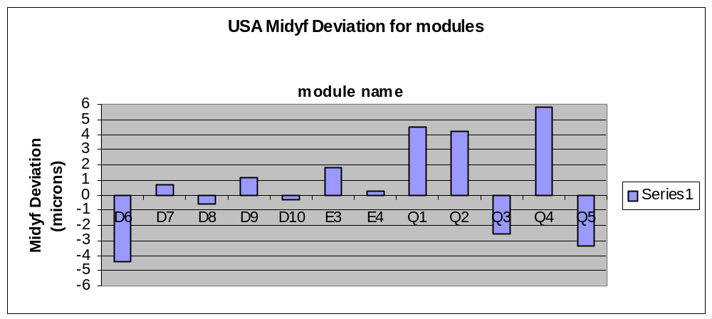
With regard to this plot, we note that modules D6-D10 used baseboards with epoxy hole washers, E3 and E4 used baseboards with old style Aluminum washers and Q1-5 used baseboards with new production style Aluminum washers.

- loCoolFacing “a” deviates from nominal in a similar way to module Q3. For the same reason we don’t consider this to be a failure either. We measured the total thickness across the cooled facings on this module with a micrometer. Near the hole we find 0.91 mm and near the slot we find 0.96 mm. This deviation from parallel in the baseboard/facing sandwich is actually in the opposite direction to the loCoolFacing angle observed but is indicative that the baseboard assembly could contribute to deviations in the survey.
- maxZerrorUpper and Lower: Throughout the qualification process we have been comparing to a common profile as stored in the Z metrology spreadsheets provided on the web. While the labeling of the common profile is ambiguous, as best we can determine, it corresponds to modules made with 100 type silicon. The silicon we used in the qualification series is also 100. However, it is clear that many of the modules we built are considerably flatter than those used to form the common profile. We also compared to the explicitly labeled 100 profile on the web and we remain flatter than that as well. See the figures below for an example. At worst we claim to be comparing to the wrong profile but as our modules are quite flat they should not fail qualification in this deviation. We suggest the maxZerrorUpper and Lower cuts should not be based simply upon the deviation from the common profile. They should instead be based on the requirement that the module bows by no more than 50 microns beyond the common profile.

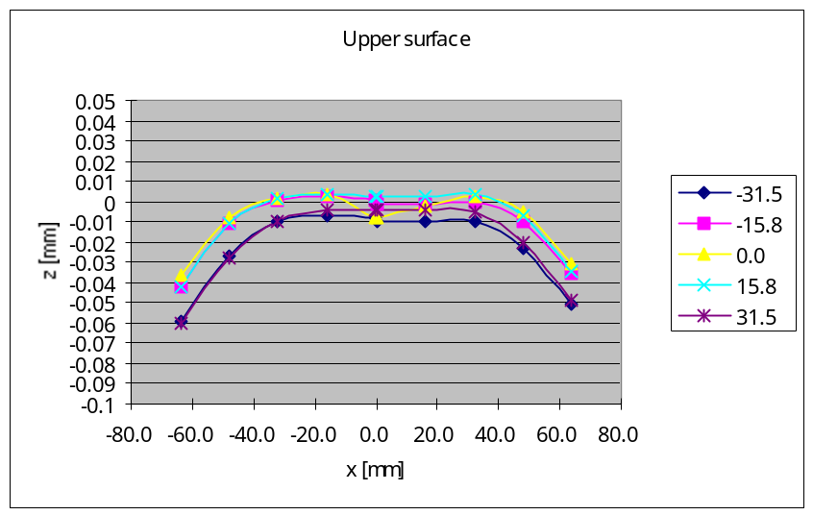
Above: The official 100 profile for the upper surface from the barrel module web page.

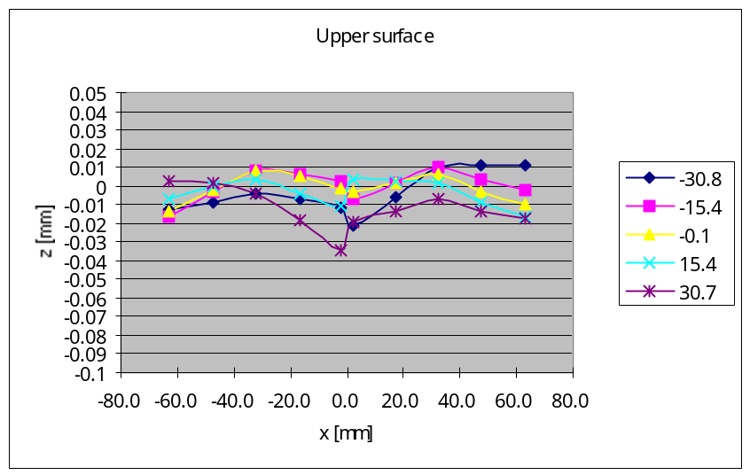
Above: Measured upper surface for USA module Q4

Based upon the performance data presented and the discussion given we consider Q4 to have passed qualification.

Q5: This module remains inside specification mechanically in X-Y and Z after full thermal cycle. This module is inside spec electrically. Following construction and test this module had 13 bad channels. Of these 7 were already bad on the wafer (chips with 1 bad channel were used on the hybrid for this module). Of the remaining 6, 3 were a contiguous triplet and thus due to a wire bond short, and probably repairable with some effort. The total leakage on the complete module was 0.49 micro-Amps at 500 Volts. Based upon the data presented, Q5 passes the qualification.

In addition we discuss the results on the pre-qualification module E3 and E4:
E3: This module remains inside specification mechanically in X-Y and Z after full thermal cycle. This module is inside spec electrically. Following construction and test this module had 14 bad channels but of these 12 were present already at ABCD wafer level (chips with 1 bad channel were used in pre-qualification). The total leakage on the complete module was 0.5 micro-Amps at 500 Volts. While not a qualification module, E3 none-the-less meets the specifications to pass qualification.

E4: This module remains inside specification mechanically in X-Y and Z after full thermal cycle. This module is inside spec electrically. Following construction and test this module had 17 bad channels, of these 9 were present already at the ABCD wafer level. Of the remaining 8, 6 are found in 3 pairs, indicating shorted wirebonds or fanout traces. In one of these pairs we found a hairline short in the fanout lithography. The other shorts are repairable with some amount of effort. The total leakage on the complete module was 0.338 micro-Amps at 500 Volts. While not a qualification module, E4 none-the-less meets the specifications to pass qualification.

3. General Discussion
- Dust: During the qualification series RAL reported the appearance of micron scale dust or debris on the detector surfaces after the assembly alignment step. This was attributed to the vacuum pickup system and the use of clean room paper which did not completely cover the silicon surface. RAL associated this dust with some increased leakage current. We saw this dust as well but not any associated leakage increase. Part way through qualification RAL recommended, and we adopted, a larger clean room paper cover sheet. With the larger paper the dust was no longer present.
- Hybrid Alignment: Hybrid alignment was incorporated into the build specification with the May 28, 2002 release of Barrel Module FDR-7. During qualification we used a temporary hybrid mounting fixture in lieu of our production model which was delayed in fabrication. The temporary fixture did not place the hybrids within the 100 micron tolerance stated in FDR-7 along the strip (Y) direction. They were placed well enough to align fanout and detector pads for straight wirebonding and to fit into the module test boxes. Since the completion of the qualification run our production hybrid placement fixture has been commissioned and we have mounted mechanical grade hybrids on dummy modules with a deviation of 25-40 microns from nominal along the strip direction and about 25 microns across the strips. We do not foresee any difficulty to meet the hybrid mounting specification in production.\
- Wirebonding: As demonstrated by the good channel yields seen on all the qualification and pre-qualification modules our wire bonding has been reliable. This result however masks a number of difficulties experienced in the process and reported on during the Valencia SCT week. We had difficulty to bond from detector to detector particularly in the regions close to channels 1,2,3…. Because of this we had to repeat bond to some pads and this was time consuming and frustrating for the operators. After considerable study and consultation with the bonding machine technical support staff and other experts we concluded that there may be two sources for these difficulties.
- In the difficult region, the bond pads are quite far from the nearest Araldite/BN glue dots. The silicon is therefore cantilevered and is seen to deflect significantly under the bonding tool. No simple variation of bonding parameters improves the bonding.
- The bonding machine force, set by a mechanical adjustment and force gauge measurement, is at the manufacturer’s default value. By lowering this, and making other adjustments on controllable bonding parameters, the difficulties in this region might be reduced.
In parallel with our qualification work we made extensive studies of effect of glue dot position also using dummy parts. We plan to also study the effect of reduced bond force. With a modified glue pattern shown below, we observed a significant and dramatic improvement in bonding reliability in the difficult region. Following our study of reduced bond force we will consider requesting of the barrel module community permission to modify the glue pattern as shown. We can foresee no effect on thermal or mechanical performance from such a modified pattern.



