Module Bonding Operation Manual
Lawrence Berkeley National Laboratory
Rhonda Witharm Version 1.0, July 16, 2002
Revision History
V1.0 Original Version 16-July-2002

1. Place module in module bonding fixture, attach to base plate with two screws.
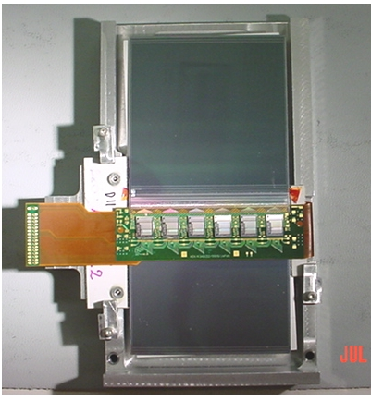
2. Set Z height on detector at 2400.

- Start with the detector-to-detector bonding program, inner row #00000029. This program bonds half the detector. After first half is done, restart program at mid detector to finish row.

Load floppy disk, press “floppy” button on front panel then press play. The program number will appear, press the accept button. The program will load. When it flashes, “program loaded”, press semi-auto button and start lining up the reference points.

  - Reference points for detector-to-detector program are as follows.

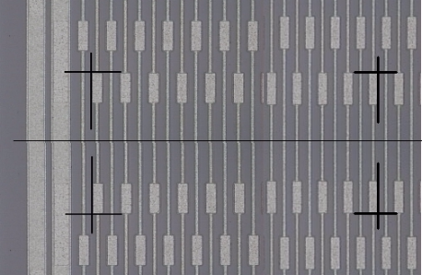
It is divided into three devices and uses three sets of reference points, which correspond with three chips.

xyo
Enter these reference points three times which will take you to the middle of the detector and the first half of the detector will be bonded.
Power 1st bond is 2.2, 2nd bond is 1.9 loop height is 300

3.2 Repeat this program starting from where it ended to finish the row. There will be one bond at the end of the row which will be bonded in manual.

- Next do the outside row, detector-to-detector program, #00000030.The set up is the same as the inner row but the reference points are on the outer row. Loop height is 500.

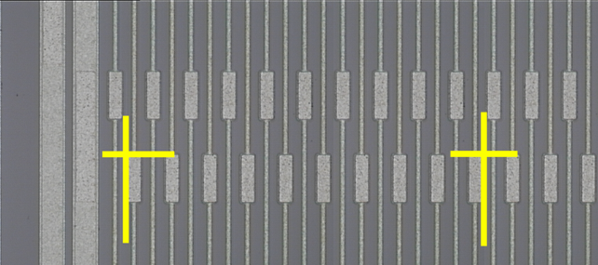5. Fan out–to-detector program, #00000027
This program is similar to the detector-to-detector program in that it bonds half of a fan out then
needs to be restarted to finish the second half.
It also uses three sets of reference points.
Loop height is 700

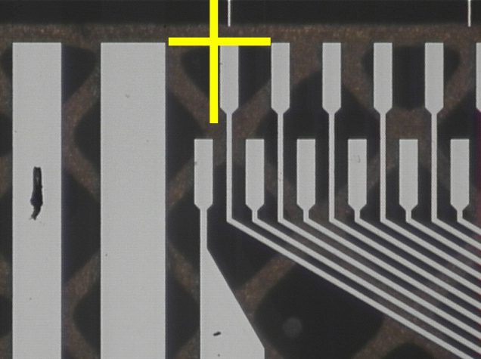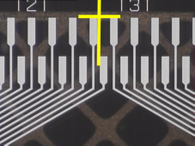 Power for 1st bond on fan out is 2.2

2nd bond on detector is 1.9

xyo and ref #1

6. Fan out –to- detector, outer row program, #00000028
The same as #00000027. Pay attention to the reference points. The first pad on the left is not used as a reference point. When the program is restarted to finish the row, one left over bond at the end will need to be bonded in manual as well as this first one. Bond from fan out to detector.
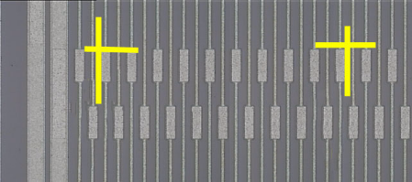
Power 1st bond is 2.2
2nd is 1.9
Loop height is 900

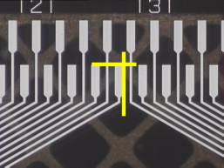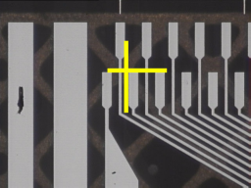
xyo and ref #1

- Chip- to- fan out, inner row program, #00000020
This bonds the inner row of one chip. It references three devices, the fan out, the chip and the gold crosses on the hybrid near the corner of the chip. After the row of bonds has been completed, the bonder jumps down to the gold pad and bonds up to the fan out for two bonds on either side of the chip.
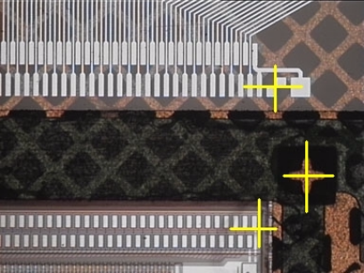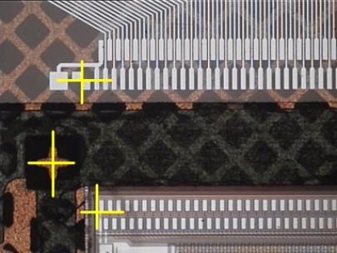

Loop height is 300

xyo, ref #1

3rd device

2nd device

- Chip-to-fan out, outer row program, #00000026, has the same xyo, ref #1 and 3rd device, but the 2nd device references are on the outer row.

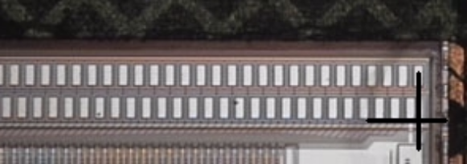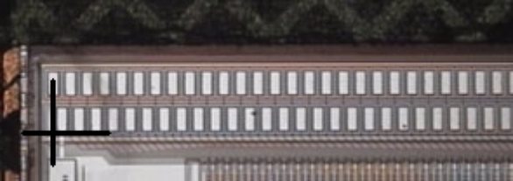

Loop height is 400

